|  |
| --- |
| WIF2003 – WEB PROGRAMMING PHASE 2 |
| USER MANUAL REPORT |
| PERSONAL FINANCIAL MANAGEMENT |

INSTRUCTOR: DR. CHIAM YIN KIA

PREPARED BY:

|  |  |
| --- | --- |
| NAME | MATRIC NO |
| MUHAMMAD TAQIUDDIN BIN SHOKORDEY | WIF160072 |
| SITI NOOR KHAIRANI BINTI AFIFFUDDEN | WIF160076 |
| SYAHIRA ADRINA BINTI SYARUL NIZAM | WIF160056 |
| AMAL MOHAMMED ALI OTHMAN AZAZI | WIF160705 |

**TABLE OF CONTENTS**

INTRODUCTION 2

HOMEPAGE – PERSONAL FINANCIAL MANAGEMENT 3

REGISTER AS NEW MEMBER 4

LOGIN 5

EXPENSE PAGE 6

EXPENSE REPORT PAGE 7

INCOME/SALARY PAGE 8

SALARY LIST PAGE 9

LOGOUT 10

# **INTRODUCTION**

Personal Financial Management Web Site is a web site that allow registered users to manage and handle their finance. It allows user to manage their daily expense and income in which the system will calculate the total of their expenses and incomes. This is important as it will help users to manage their finance better.

The web site was designed for ease of usage, so user will be able to handle the user interface fast and easy. The GUI used was also simple with the implementation of simple colour that is easy to the eye. The site also only allows registered users to key in their transaction and only those users will be able to access their own personal financial transactions.

The web site template and source code is built entirely from HTML, Express, Node.js, Javascript and MongoDB as its database platform. User can access the site by downloading the source code form the Github link provided and access through localhost:3000 on their browser.

Github link: **https://github.com/syahiraadrina/WEB-PROGRAMMING---PHASE-2-**

# **HOMEPAGE – PERSONAL FINANCIAL MANAGEMENT**

Link: localhost:3000/homepage

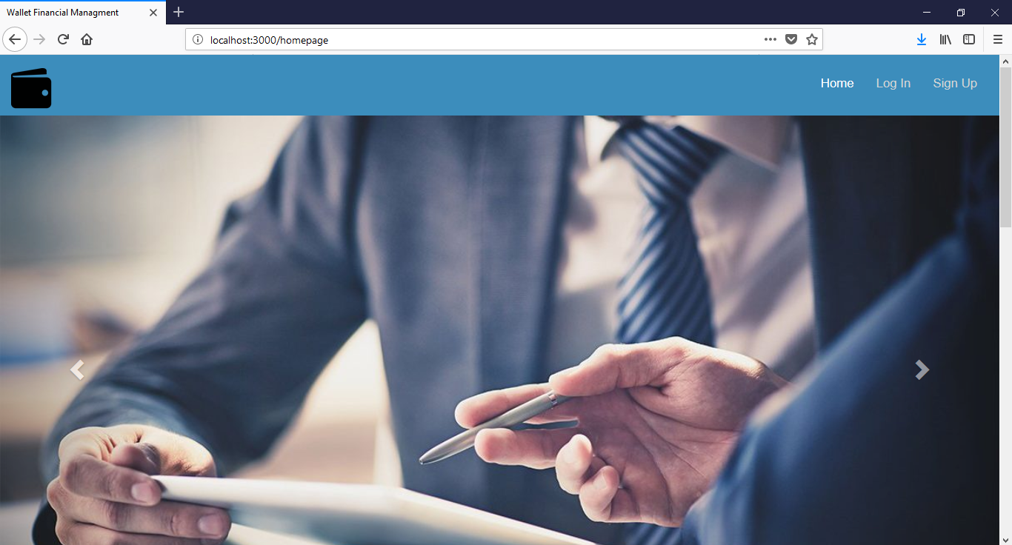

Once user has access to **localhost:3000/homepage**, they will be directed to this page. There a few tasks that can be done such as **Login** or **Sign up**.

To be able to use the function available in the web site, user must registered first. This can be done by clicking the **Sign Up button**.

However, previously registered users can straight away login to the website by clicking the **Log In button.**

# **REGISTER AS NEW MEMBER**



CLICK HERE TO REGISTER

**Site Registration**

Users who have not previously registered for the Personal Financial Management Web Application must select **“Sign Up”** to access the **“Sign Up Form”** page.

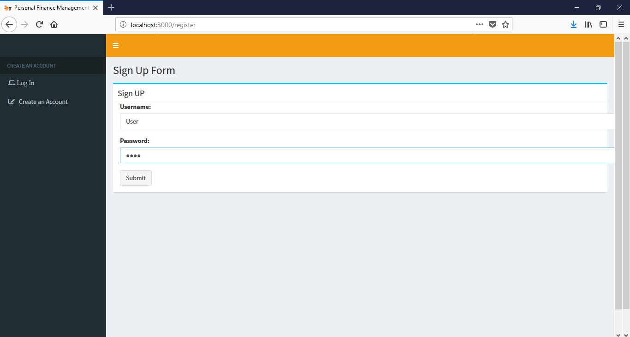

3

2

1

To register:

1. Input your chosen **Username** that you will be able to remember as it will be used for login.
2. Input your own personal **Password** that is unique to you. This is important to be remembered as it will also be used for login.
3. Click the **“Submit”** button once you finish inserting your username and password.

# **LOG IN**



CLICK HERE TO LOGIN

Users who have previously registered for the web site can click the “Login” button to login the system.

Users will be directed to the **“Sign In”** page.

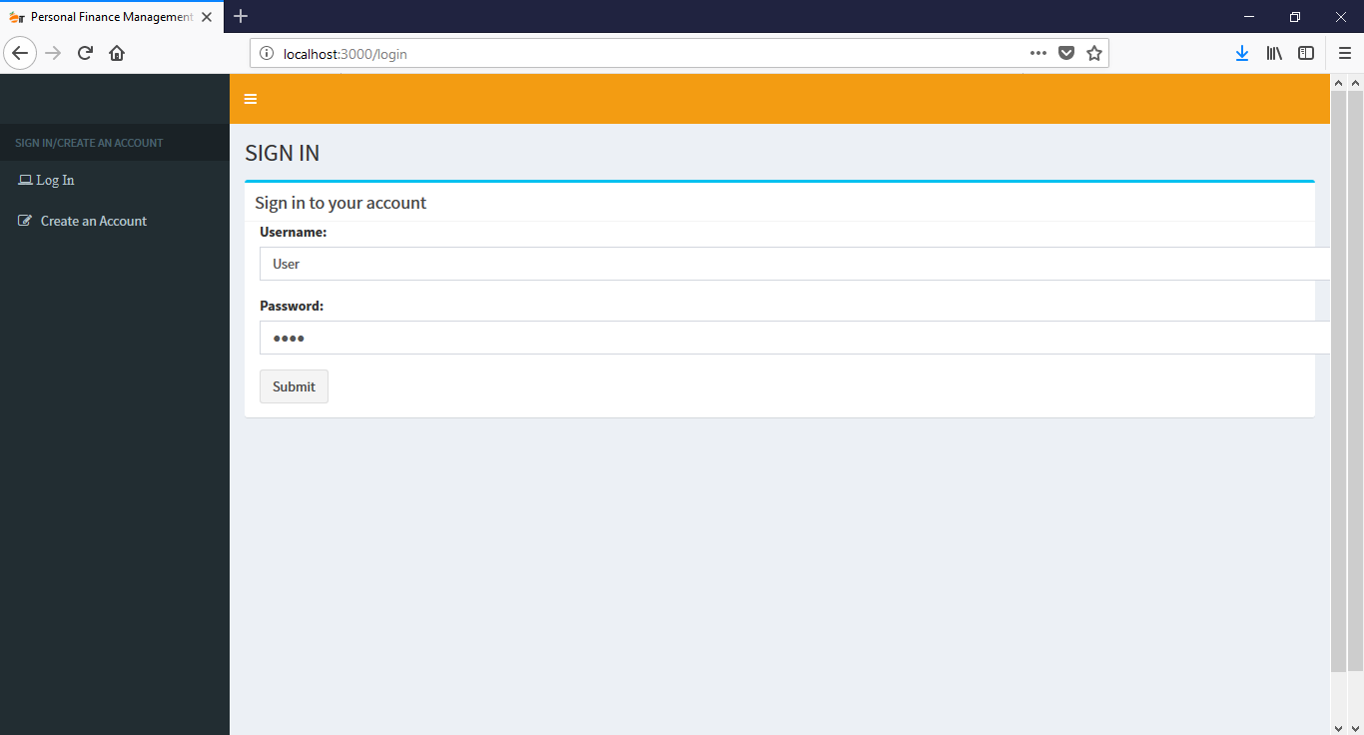

3

2

1

To login:

1. Enter your registered **Username**
2. Enter your registered **Password** for the Username.
3. Click the “Submit” button once you finish inserting your username and password.

# **SET EXPENSE PAGE**

Once login, users will be directed to the expense page in which they can manage their expenses. Users can access the “**Set Expenses”** page by clicking the “**Set Expenses”** button at the sidebar

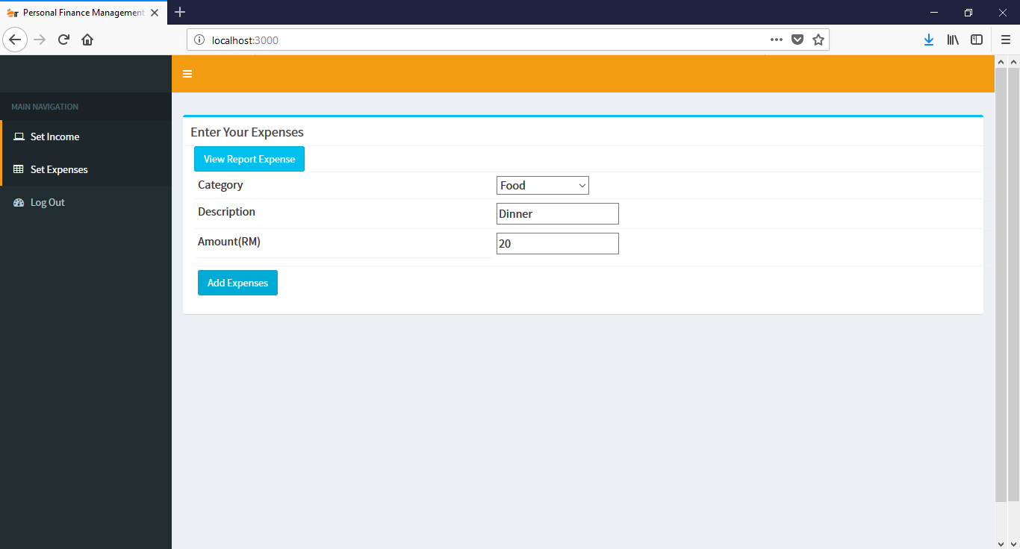

iii. Enter expense amount

ii. Enter expense description

i. Click here

B

A

There are two tasks that can be done in this page, which is **“Add Expense”** **and “View Report Expense”**.

1. **View Report Expense button**
   1. Once click, user will be directed to the **Expense Report** page.
2. **Add Expenses button**
   1. To add new expense, user has to:
      1. Chose the **Category** of their expenses; click the dropdown button to see the categories available.
      2. For **Description,** user can enter the description of their expenses; Example: Dinner.
      3. For **Amount(RM)**, user has to enter and state the amount they spend for the particular expense; Example: 20
      4. Click the **Add Expenses** buttonto submit the new expense entry.

# **EXPENSE REPORT PAGE**

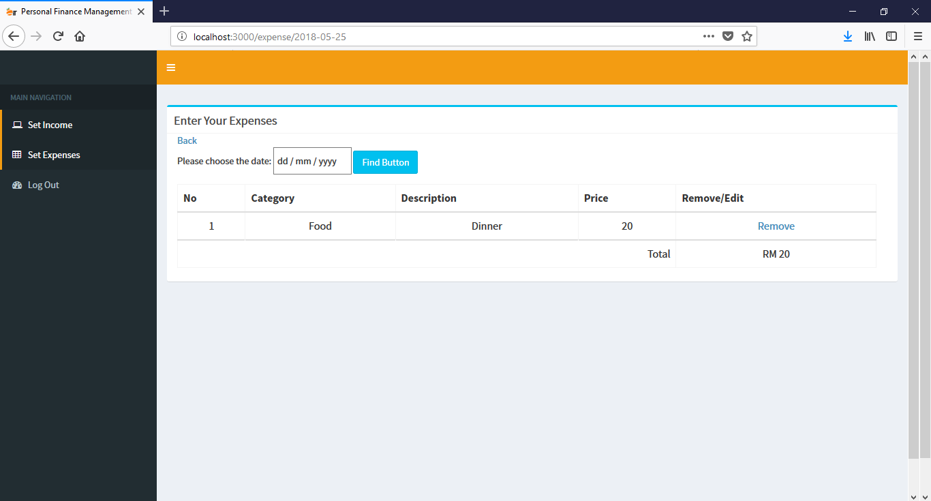

A

B

If user click **“View Report Expense”,** they will be directed to this page to view their expenses entry and report. The total of their expenses will be display.

1. **Search by date.**
   1. User has to enter date in the format of **day/month/year** to search for particular expenses by date.
   2. Click **Find Button** to search.
2. **Remove button.**
   1. User can delete/remove any expenses entry that they did or deemed unnecessary.
   2. Click the **Remove** button to remove any entry.

# **SET INCOME/SALARY PAGE**

Once login, users can access the “**Set Income”** page by clicking the “**Set Income”** button at the sidebar

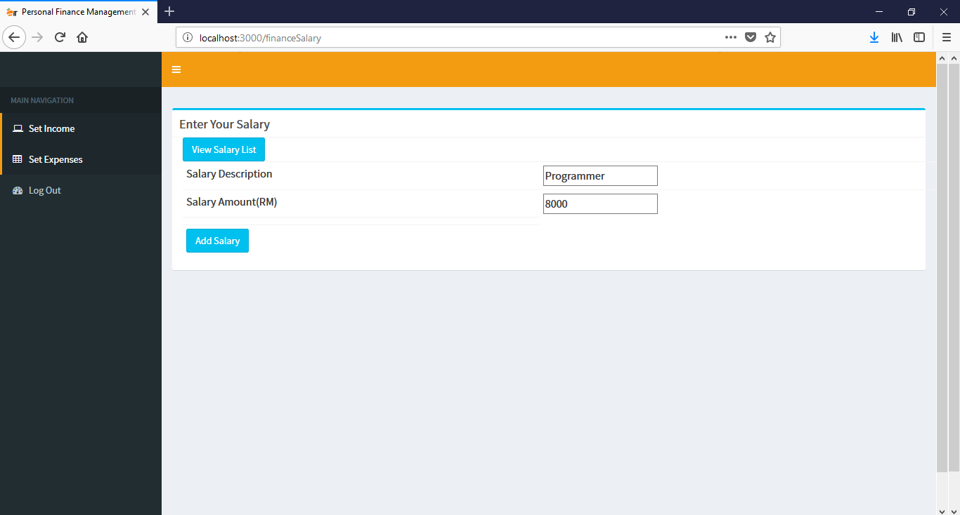

i. Enter salary description

ii. Enter salary amount

B

A

There are two tasks that can be done in this page, which is **“Add Salary”** and **“View Salary List”.**

1. **View Salary List button**
   1. Once click, user will be directed to the **Salary List** page.
2. **Add Salary button**
   1. To add new salary, user has to:
      1. For **Description,** user can enter the description of their salary; Example: Programmer.
      2. For **Amount(RM)**, user has to enter and state the amount they received for the particular salary; Example: 8000
      3. Click the **Add Salary** button to submit the new salary entry.

# **SALARY LIST PAGE**

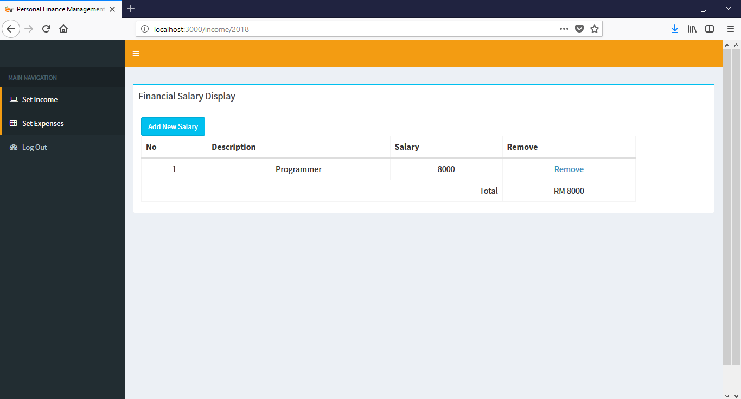

B

A

If user click **“View Salary List”,** they will be directed to this page to view their salary entry and report. The total of their salary will be display.

1. **Add New Salary button.**
   1. Click **Add New Salary** to add new salary to the list. User will be directed to **Salary Page.**
2. **Remove button.**
   1. User can delete/remove any salary entry that they did or deemed unnecessary.
   2. Click the **Remove** button to remove any entry.

# **LOGOUT**

To logout of the system, user can click the “Log Out” button at the sidebar anytime they want.



CLICK TO LOGOUT

Once logout, user will be directed to the login page.